Some NUMA commands :-

$numastat :- Show per-NUMA-node memory statistics for processes and the operating system
For more info do $man numastat
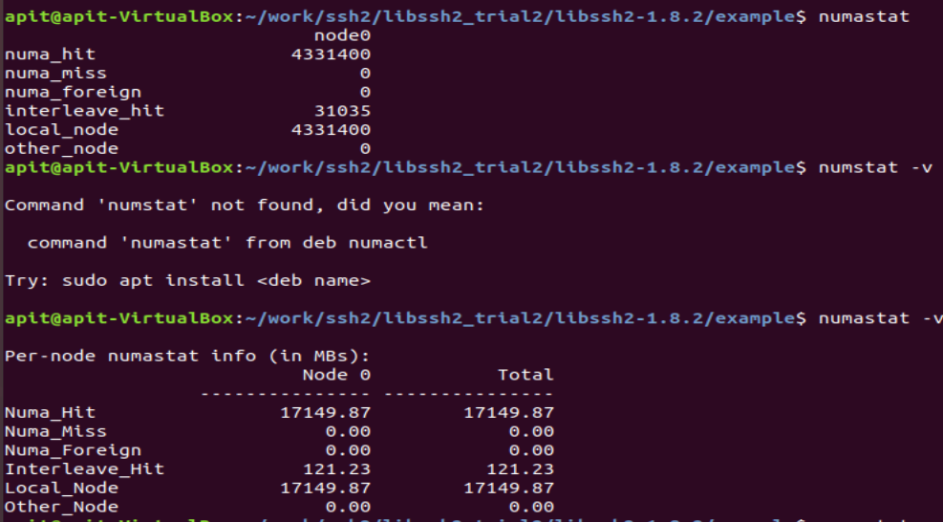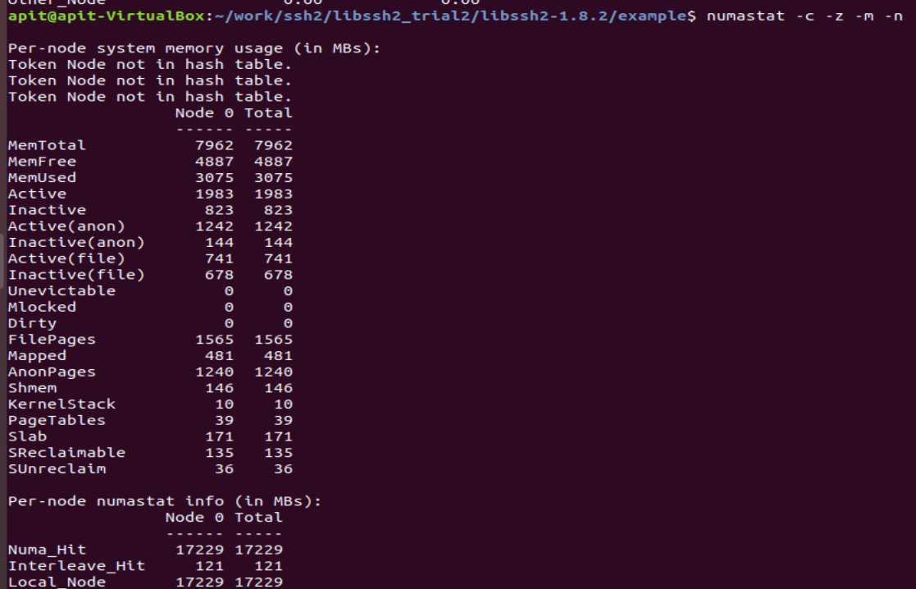

/proc/[number]/numa_maps (since Linux 2.6.14)
This file displays information about a process's NUMA memory policy and allocation.

$numactl - Control NUMA policy for processes or shared memory

numactl runs processes with a specific NUMA scheduling or memory placement policy. The policy is set for command and inherited by all of its children. In addition it can set persistent policy for shared memory segments or files.

$numactl --hardware => shows the list of nodes on the current hardware

$numactl --interveave=all program -opts args
$numactl --preferred=1 program -opts args
$numactl --localalloc --file/dev/shm/file

All above three command are option set for allocation policy for process to interleaved , preferred, local NUMA policy respectively.

Here in third command --file option is used with a tmpfs shared memory files.
It can be used with any of the four policy option to determine how the shared memory will be allocated .

$numactl --cpubind=0 --membind =0,1 program -opts args

The --cpubind and membind option implement the Bound NUMA allocation policy . This use of numactl restrict execution of a program to a specific list of CPUs and memory is allocated fom the specified list of nodes

$numactl --show => display the NUMA allocation policy inherited from the shell

$numastat => displays counters that indicate how well memory is being allocated for each node each.

Cat /sys/device/system/*/meminfo =>

$ cpuset cgroup => cpuset.cpus and cpuset.mems tunable basically to assign cpu and memory nodes to process and there childs

